Google Charts

References

1. <https://developers.google.com/chart/interactive/docs/quick_start>
2. <http://www.tutorialspoint.com/googlecharts/>

Exercises

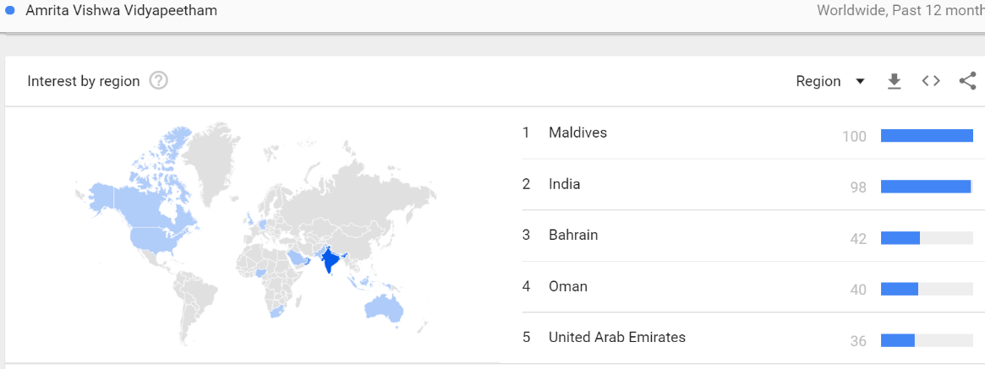

Load the Data

Step 1 : How to load the Google Chart libraries?

<script type="text/javascript" **src="https://www.gstatic.com/charts/loader.js"**></script>  
<script type="text/javascript">  
  **google.charts.load('current', {packages: ['corechart']});**  
  **google.charts.setOnLoadCallback(drawChart);**  
  ...  
</script>

The first line of this example loads the loader itself.

You can only load the loader one time no matter how many charts you plan to draw.

After loading the loader, you can call the google.charts.load function one or more times to load packages for particular chart types.

The first argument to google.charts.load is the version name or number, as a string.

If you specify 'current', this causes the latest official release of Google Charts to be loaded.

If you want to try the candidate for the next release, use 'upcoming' instead

You want to display a corechart (bar, column, line, area, stepped area, bubble, pie, donut, combo, candlestick, histogram, scatter).

If you want a different or additional chart type, substitute or add the appropriate package name for corechart above (e.g., {packages: ['corechart', 'table', 'sankey']}.

<head>  
  <script type="text/javascript" **src="https://www.gstatic.com/charts/loader.js"**></script>  
  <script type="text/javascript">  
    google.charts.load('current', {packages: ['corechart']});  
    google.charts.setOnLoadCallback(drawChart);  
  
    function drawChart() {  
      // Define the chart to be drawn.  
      var data = new google.visualization.DataTable();  
      data.addColumn('string', 'Element');  
      data.addColumn('number', 'Percentage');  
      data.addRows([  
        ['Nitrogen', 0.78],  
        ['Oxygen', 0.21],  
        ['Other', 0.01]  
      ]);  
  
      // Instantiate and draw the chart.  
      var chart = new google.visualization.PieChart(document.getElementById('myPieChart'));  
      chart.draw(data, null);  
    }  
  </script>  
</head>  
<body>  
  <!-- Identify where the chart should be drawn. -->  
  <div id="myPieChart"/>  
</body>

Prepare the Data

**// Create the data table.  
      var data = new google.visualization.DataTable();  
      data.addColumn('string', 'Topping');  
      data.addColumn('number', 'Slices');  
      data.addRows([  
        ['Mushrooms', 3],  
        ['Onions', 1],  
        ['Olives', 1],   
        ['Zucchini', 1],  
        ['Pepperoni', 2]  
      ]);**

A  DataTable is a two-dimensional table with rows and columns, where each column has a datatype, an optional ID, and an optional label. The example above creates the following table:

|  |  |
| --- | --- |
| type: string label: Topping | type: number label: Slices |
| Mushrooms | 3 |
| Onions | 1 |
| Olives | 1 |
| Zucchini | 1 |
| Pepperoni | 2 |

Customize the Chart

**var options = {'title':'How Much Pizza I Ate Last Night',  
                     'width':400,  
                     'height':300};**

Every chart has many customizable options, including title, colors, line thickness, background fill, and so on. Although the Chart Tools team has worked hard on the default chart appearance, you might want to customize your chart, for example to add titling or axis labels.

var options = {

'legend':'left',

'title':'My Big Pie Chart',

'is3D':true,

'width':400,

'height':300

}

**Draw the Chart**

## **Instantiate your chart**

  var chart = new google.visualization.PieChart(document.getElementById('chart_div'));

Your page must have an HTML element (typically a <div>) to hold your chart. You must pass your chart a reference to this element, so assign it an ID that you can use to retrieve a reference using document.getElementById().

Every chart supports a draw() method that takes two values: a DataTable (or a DataView) object that holds your data, and an optional chart options object. The options object is not required, and you can ignore it or pass in null to use the chart's default options.

# Draw Multiple Charts

// Draw the pie chart for Sarah's pizza when Charts is loaded.  
      google.charts.setOnLoadCallback(drawSarahChart);  
  
      // Draw the pie chart for the Anthony's pizza when Charts is loaded.  
      google.charts.setOnLoadCallback(drawAnthonyChart);  
+++++++++++++++++++++++++++++++++++++++++++++++++++++++++++++++++++++++

<table class="columns">  
      <tr>  
        <td><div id="Sarah_chart_div" style="border: 1px solid #ccc"></div></td>  
        <td><div id="Anthony_chart_div" style="border: 1px solid #ccc"></div></td>  
      </tr>  
    </table>